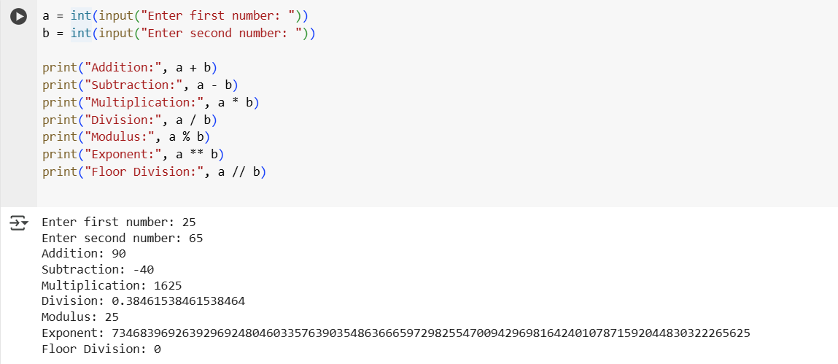

Q1. Write a program for arithmetic operators

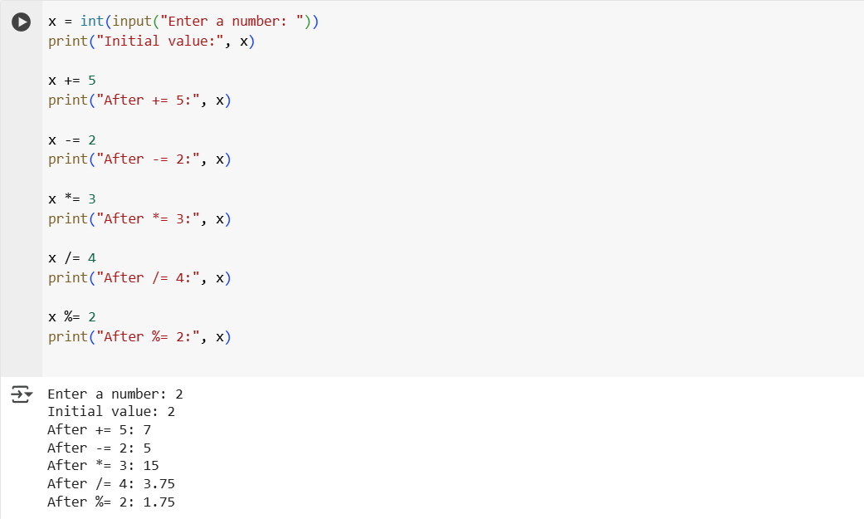

Q2. Write a program for assignment operators

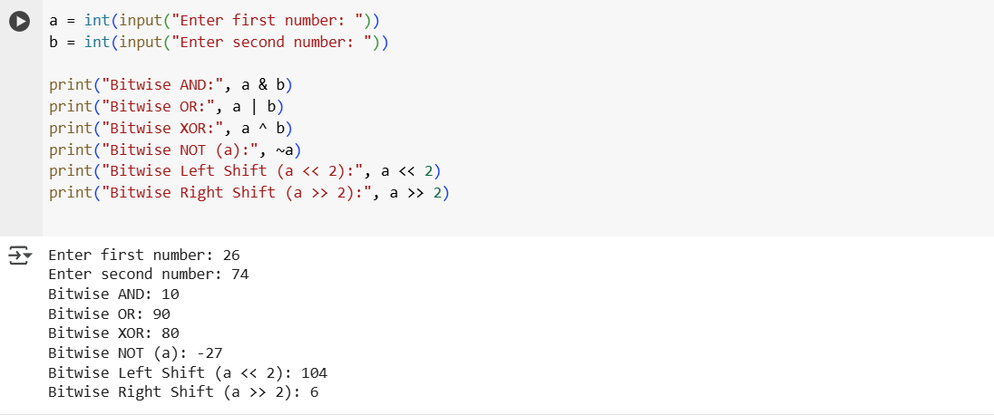

Q3. Write a program for Bitwise operators.

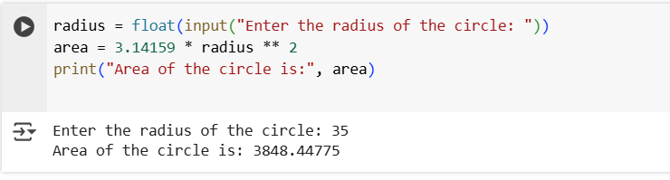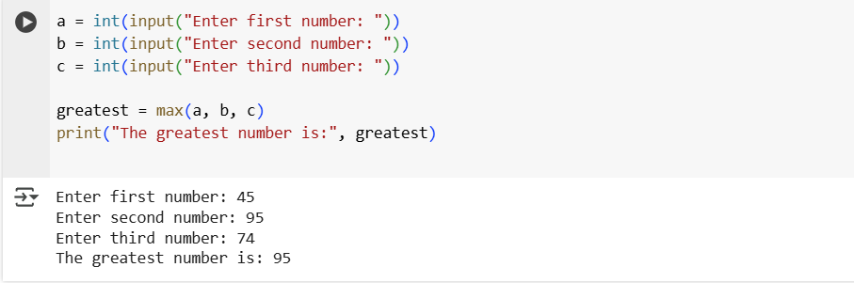

Q5. Calculate the area of a circle.

Q4. Write a program to calculate greatest of three numbers.

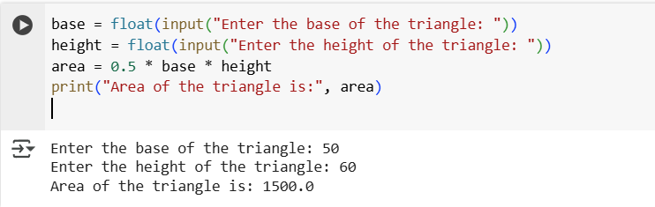

Q6. Calculate the area of triangle

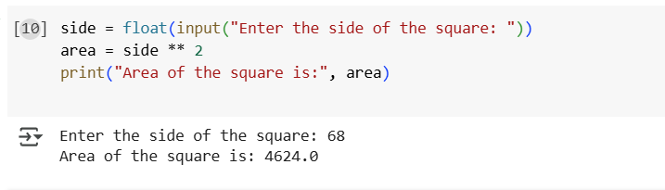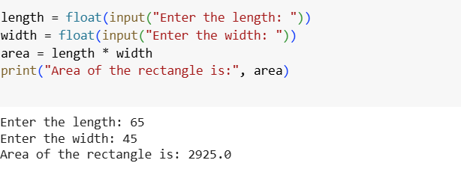

Q7. Calculate the area of Square.

Q7. Calculate the area of Rectangle.